VAMSIKRISHNA I

421118104093

lll – CSE – C

ARRAY ASSIGNMENT – PART – 1

1

import java.util.\*;

class main

{

public static void main(String args[])

{

int n,sum=0;

float avg;

Scanner sc = new Scanner(System.in);

System.out.println("Enter no.of elements:");

n=sc.nextInt();

int a[]=new int[n];

System.out.println("Enter elements:");

for(int i=0;i<n;i++)

{

a[i]=sc.nextInt();

sum=sum + a[i];

}

System.out.println("sum:"+sum);

avg=(float)sum / n;

System.out.println("average:"+avg);

}

}

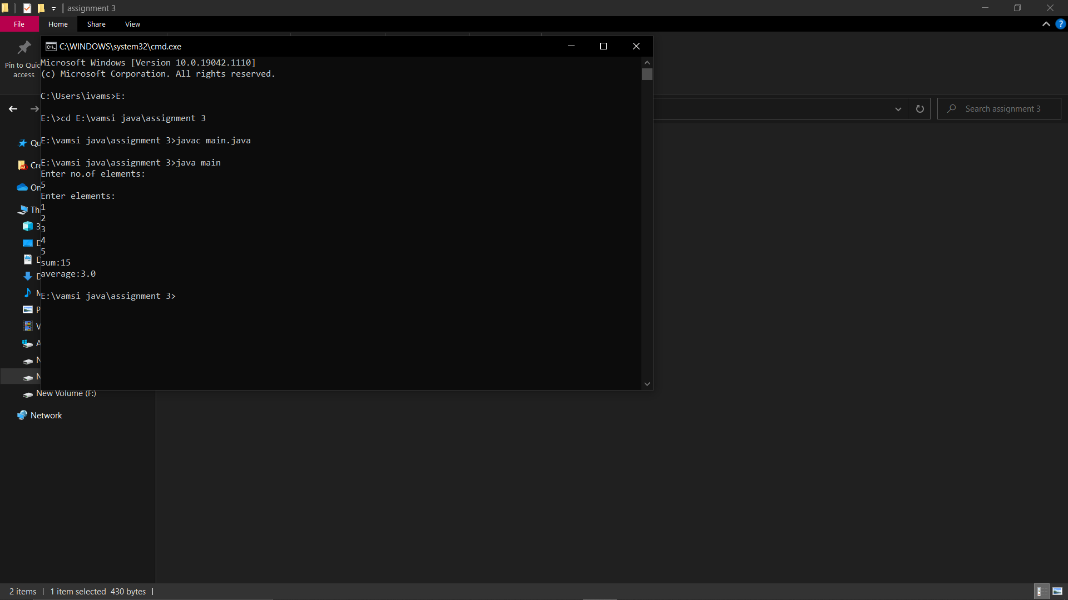

2

class main1{

public static void main(String args[]){

int array[] = new int[]{10, 11, 88, 2, 12, 120};

int max = getMax(array);

System.out.println("Maximum Value is: "+max);

int min = getMin(array);

System.out.println("Minimum Value is: "+min);

}

public static int getMax(int[] inputArray){

int maxValue = inputArray[0];

for(int i=1;i <inputArray.length;i++){

if(inputArray[i] >maxValue){

maxValue = inputArray[i];

}

}

return maxValue;

}

public static int getMin(int[] inputArray){

int minValue = inputArray[0];

for(int i=1;i<inputArray.length;i++){

if(inputArray[i] <minValue){

minValue = inputArray[i];

}

}

return minValue;

}

}

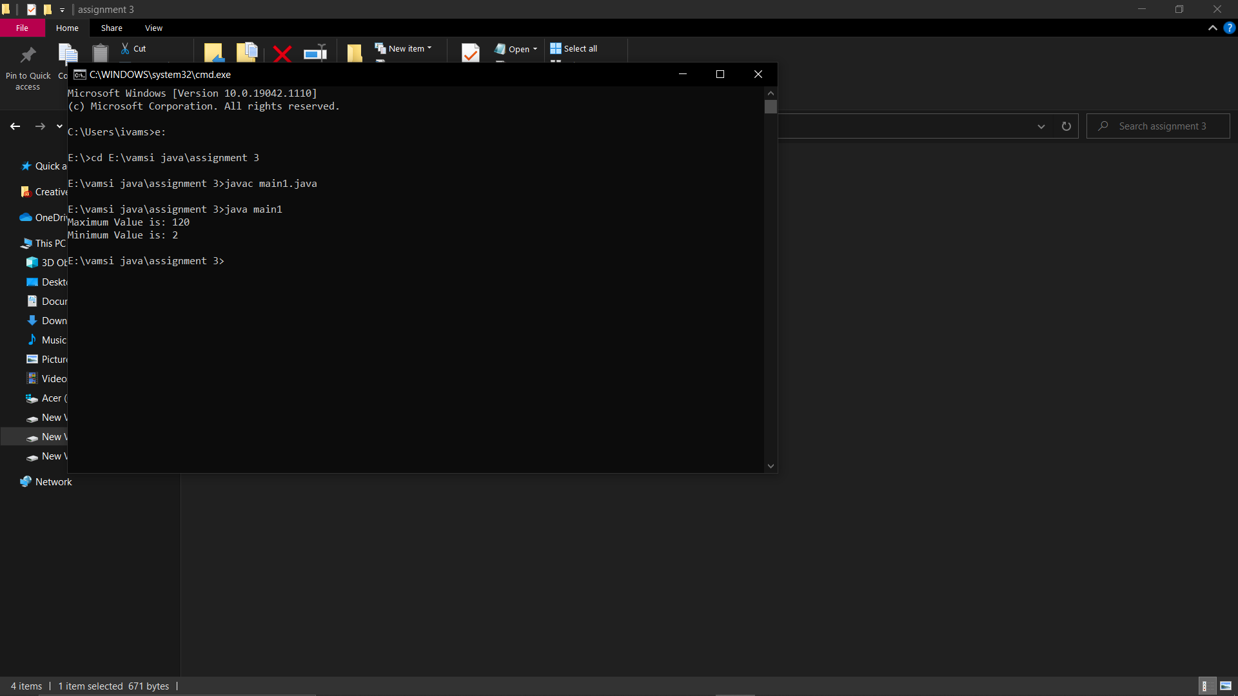

3

import java.util.\*;

public class main2 {

public static void main(String[] args)

{

int n,i,a1;

Scanner sc=new Scanner(System.in);

System.out.print("Enter no.of elements:");

n=sc.nextInt();

int[] a = new int[n];

System.out.print("Enter elements:");

for(i=0;i<n;i++)

{

a[i]=sc.nextInt();

}

System.out.print("Enter element to find:");

a1=sc.nextInt();

for(i=0;i<n;i++)

{

if(a1 == a[i] )

{

System.out.print(" "+i);

i++;

break;

}

else{

System.out.print("-1");

}}}

}

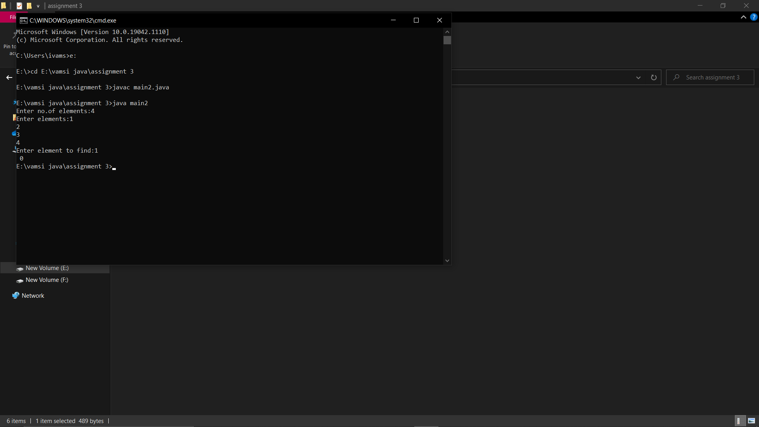

4

class main3

{

public static void main(String args[])

{

int a[]={72,33,74,141};

for(int i=0;i<a.length;i++)

{

System.out.print((char)a[i]+" ");

}

System.out.println();

}

}

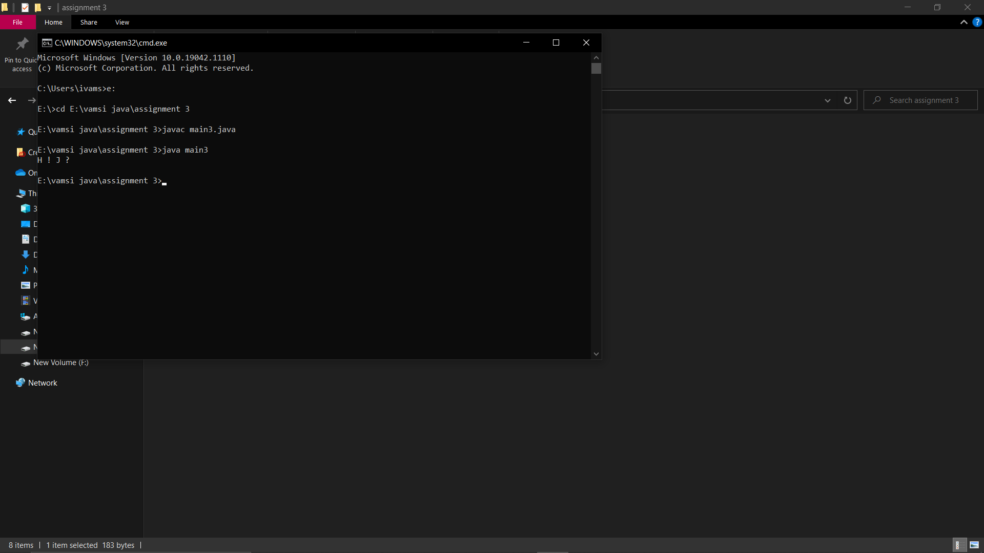

5

class main4

{

public static void main(String args[]) {

int c=0,d=0;

int a[]=new int[]{2,20,34,12,67};

int smallest=a[0];

int largest=a[0];

for(int i=0;i<a.length;i++){

if(a[i]<smallest && d<2){

smallest=a[i];

d++;

System.out.println("smallest:"+smallest);

}

if(a[i]>largest && c<2){

largest=a[i];

c++;

System.out.println("largest: "+largest); }}

}}

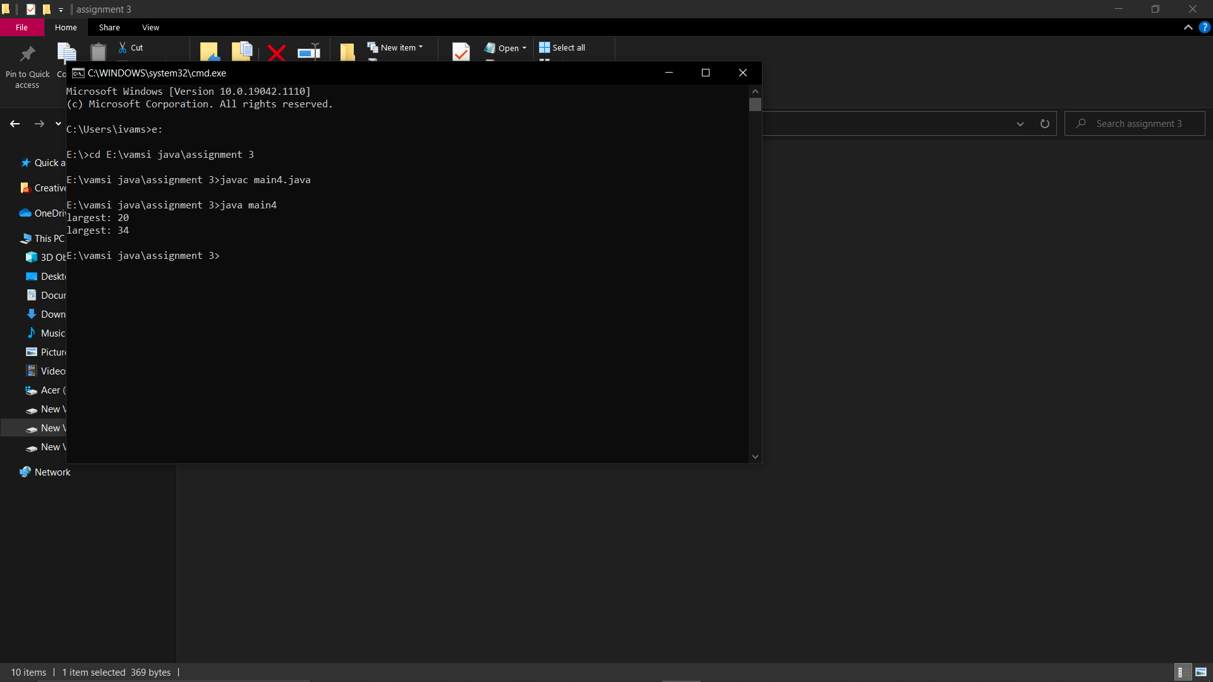

6

class main5

{

public static void main(String args[])

{

int[] arr=new int[]{5,2,8,7,1};

int temp=0;

for(int i=0;i<arr.length;i++){

for(int j=i+1;j<arr.length;j++){

if(arr[i]>arr[j])

{

temp=arr[i];

arr[i]=arr[j];

arr[j]=temp;

}

}

}

System.out.println();

System.out.println("sorted arrays");

for(int i=0;i<arr.length;i++)

{

System.out.print(arr[i]+" ");

}

}

}

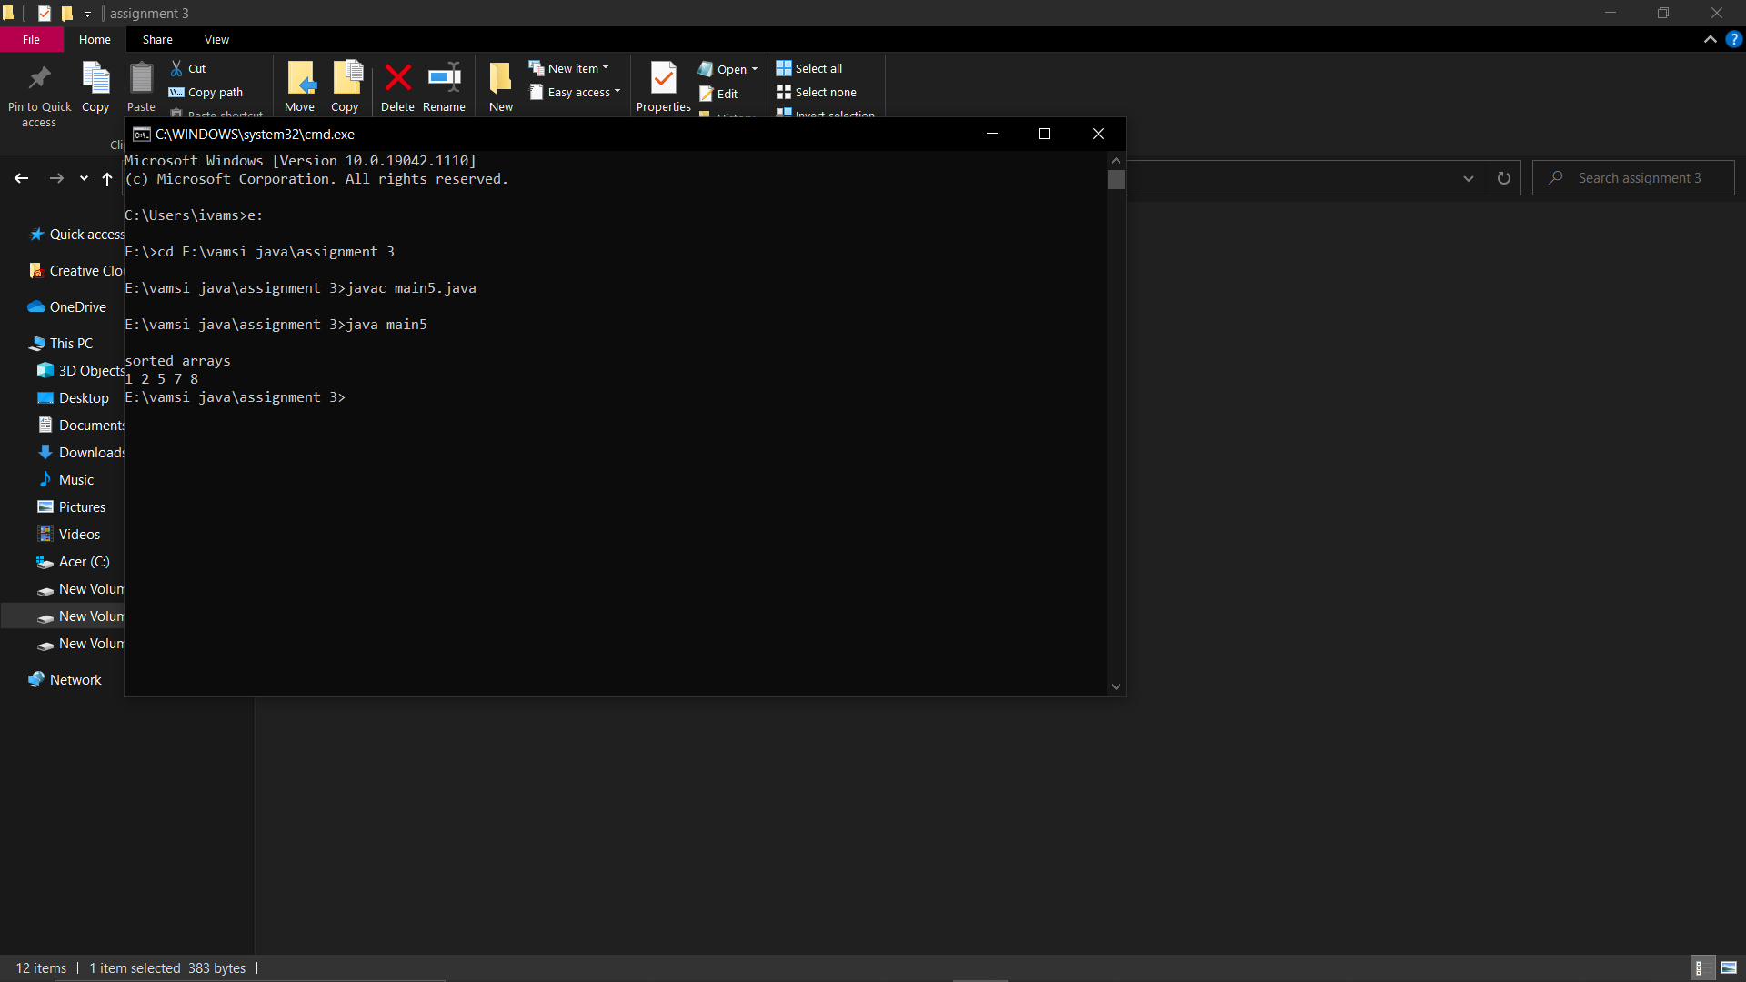

7

class main6{

public static int removeDuplicateElements(int arr[], int n){

if (n==0 || n==1){

return n;

}

int[] temp = new int[n];

int j = 0;

for (int i=0; i<n-1; i++){

if (arr[i] != arr[i+1]){

temp[j++] = arr[i];

}

}

temp[j++] = arr[n-1];

for (int i=0; i<j; i++){

arr[i] = temp[i];

}

return j;

}

public static void main (String[] args) {

int arr[] = {10,20,20,30,30,40,50,50};

int length = arr.length;

length = removeDuplicateElements(arr, length);

for (int i=0; i<length; i++)

System.out.print(arr[i]+" ");

}

}

